Batch: B2 Roll No.: 16010121200

Experiment / assignment / tutorial No. 7

Grade: AA / AB / BB / BC / CC / CD /DD

Signature of the Staff In-charge with date

Experiment No.:7

TITLE: Building and configuring simple topology using Network tool - CISCO PACKET TRACER.
______________________________________________________________________________
AIM: To build and configure VLAN (Virtual LAN) using CISCO Packet Tracer.

Packet Tracer is a network simulation program that allows students to experiment with network behaviour and ask “what if” questions. Packet Tracer provides simulation, visualization, and authoring, assessment, and collaboration capabilities and facilitates the teaching and learning of complex technology concepts.
_____________________________________________________________________________
Expected Outcome of Experiment:
CO1: Explain the fundamentals of the data communication networks, reference models,
topologies, physical media, devices, simulators and identify their use in day-to-day networks.
CO3: Demonstrate various network layer protocols and network design using IP addressing
concepts.
_______________________________________________________________
Books/ Journals/ Websites referred:
- http://www.google.com
- A. S. Tanenbaum, “Computer Networks”, Pearson Education, Fourth Edition
- B. A. Forouzan, “Data Communications and Networking”, TMH, Fourth Edition
- CISCO PACKET TRACER 6.0.1 and Higher version (free download)

Pre-Lab/ Prior Concepts: Virtual LAN
A virtual local area network (VLAN) is a LAN which is not configured by physical wiring but it is configured by software. A VLAN is logical group of network devices that appear to be on same LAN despite their geographical distribution. A VLAN is implemented so that network administrators can connect a group of host in the same domain inspite of their physical location to achieve scalability and improve security features.

To subdivide a network into virtual LANs, one configures a network switch or router. Simpler network devices can partition only per physical port (if at all) , in which case each VLAN is connected with a dedicated network cable ( and VLAN connectivity is limited by the number of hardware ports available) More sophisticated devices can mark packets through tagging, so that a single interconnect ( trunk) may be used to transport data for multiple VLANs. VLAN can greatly simplify network design and deployment, because VLAN membership can be configured through software.
______________________________________________________________________________
New Concepts to be learned: Purpose of this lab is to become familiar with building Virtual Network in Packet Tracer. ______________________________________________________________________________

Stepwise-Procedure:

- Creating a simple LAN network using packet tracer:
Step 1: Select 12 PCs from the end devices and one fast ethernet switch (2950/24 ports)

Step 2: Connect PCs and switch via copper cable from the panel. Connection can be verified by appearance of all green dots on the links.

Step 3: For PCs to communicate click on PC0.
- Dialog box for PC0 appears
- Click on desktop applications by packet tracer.
- Go to IP configuration.
- Enter IP address to identify host i.e. PC0 (for example: 192.168.1.1)
- Subnet mask-by default already set one can change it as per his/her specification.

Step 4: Repeat step 3 for PC1

Step 5: Ping the PCs and check their working status.

Step 6: Simple PDU (Protocol Data Unit) to simulate network traffic by sending ICMP PDU to assess the network traffic. View simulation in simulation mode

Step 7: . Configure two VLAN in a switch in 6 verticals.
Step 8. As per design, assign membership of VLAN to port using following command
# switch port access vlan2 or vlan3
Step 9. Check status of VLAN.

IMPLEMENTATION: (printout of simulation code)

Creating LAN:
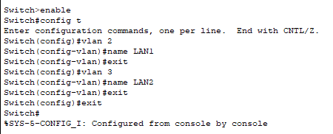

Configuring ports:
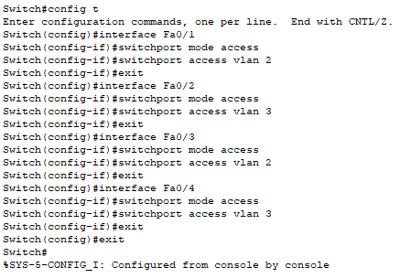

Network Design
Fig. VLAN Design
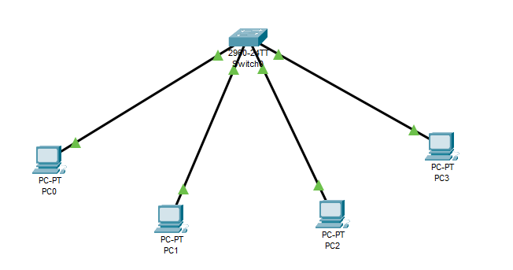

Observation:
Before creating the virtual LAN, all PCs could communicate with ech other.
After creation of VLAN, only PCs in same LAN could communicate. PCs from different LAN were not able to communicate.

Screen shots:

PC0 = 172.0.0.11
PC1 = 172.0.0.12
PC2 = 172.0.0.13
PC3 = 172.0.0.14

Before creating LAN:

PC0 able to ping PC1, PC2, PC3
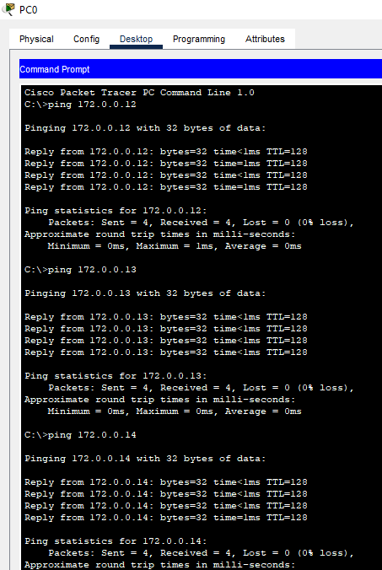

Created LAN:
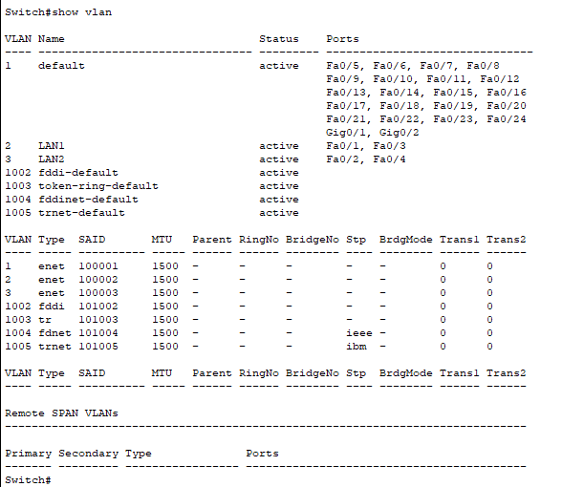

After creating LAN:

PC0 can ping PC2 but not PC1 and PC3.

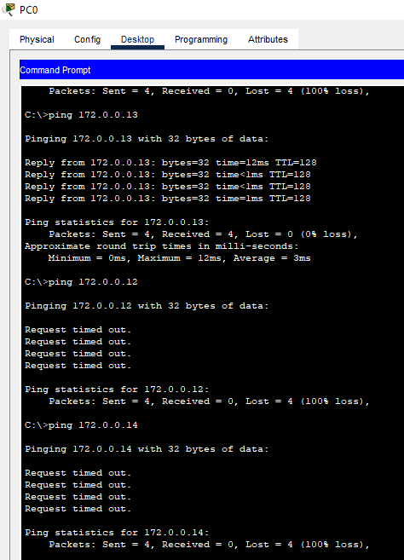

Post Lab Subjective/Objective type Questions:

- Describe the concept of Virtual LAN.
Virtual LAN (VLAN) is a concept in which we can divide the devices logically on layer 2 (data link layer). Generally, layer 3 devices divide the broadcast domain but the broadcast domain can be divided by switches using the concept of VLAN.

- Compare LAN with VLAN.
Key | LAN | VLAN
Definition | Local Area Network | Virtual Local Area Network
Cost | High | Minimal
Latency | Higher than VLAN | Very low
Devices | Hubs, Routers, Switches | Bridges, Switches
Packet Broadcasting | Packets broadcasted to each device | Packets sent to specific broadcast domain
Efficiency | Less efficient | More efficient

- State the benefits of implementing VLAN.
- Offer structure for making groups of devices, even if their networks are different.
- Increases the broadcast domains possible in a LAN.
- Reduces the security risks as the number of hosts which are connected to the broadcast domain decreases. Separate virtual LAN is configured for only the hosts having sensitive information.
- Flexible networking model that groups users depending on their departments instead of network location.
- Changing hosts/users is relatively easy. Only a new port-level configuration is needed.
- Reduce congestion by sharing traffic as individual VLAN works as a separate LAN.
- A workstation can be used with full bandwidth at each port.
- Terminal reallocations become easy.
- A VLAN can span multiple switches.
- The link of the trunk can carry traffic for multiple LANs.

CONCLUSION:

Created a VLAN using Cisco Packet Tracer.
Understood benefits of implementing a VLAN.

Date: 18/09/2023 Signature of faculty in-charge

